

Dear Parents/Carers,
Children In Need is on Friday 14th November. This year, in honour of the year 2025, BBC Children in Need are appealing to YOU to 'Challenge Yourself to 25' and do your part to change young lives. The aim is to choose a fun challenge centered around the number 25.
To raise funds, all children will be wearing non- uniform on this day. The School Council have decided sports attire would fit quite nicely with the theme of being ready for a challenge. Alongside this the team have created a challenge tick sheet for each class to try and compete as many as they can linked to the number 25- Take a look over the page to see if you can complete all 25 at home too!
We are asking the children to donate whatever they would like. All donations need to be made via the just giving link. https://www.iustgiving.com/page/rise-park-primary-
7?utm medium=FR&utm source=CL which can also be found on our school website. This will also be sent via a text message closer to the day. We will not be accepting any cash bought in to school on the day.
In addition, please note that this year we will not be having any loose change buckets in our classrooms. However, if you wish to donate more to this fantastic cause, you are welcome to do so via the Just Giving page as mentioned above. Please note that this is not an extra requirement.
We realise that times are tough for some people but we really hope that you are able to dig deep and support this fantastic cause. Last year we raised a super amount but we always aim to do even better.
Thank you in advance for your support.
Miss Scholten and The School Council
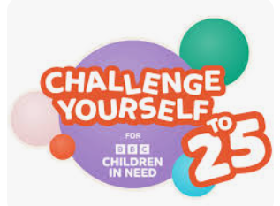
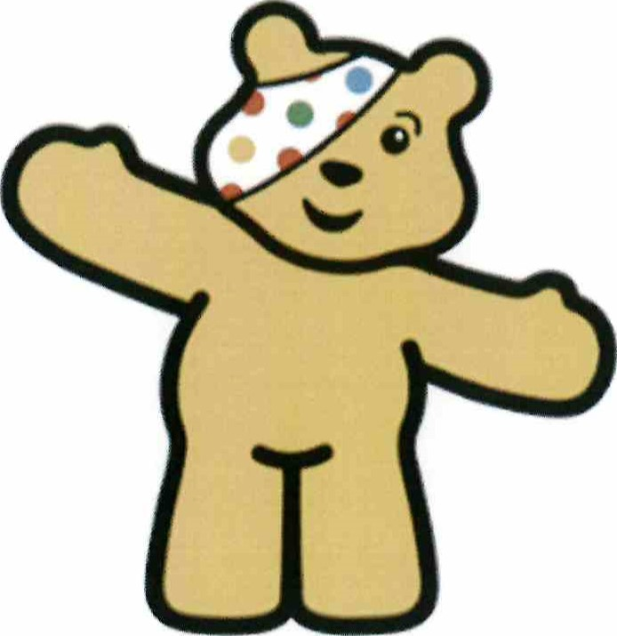

25 sit ups. | Read 25 pages of a book | Hold a plank for 25 seconds | Give out 25 compliments | Make up Q dance routine and perform It for for 25 seconds
25 star jumps | Tell 25 jokes to a friend | 25 acts of kindness throughout the day. | As a class can you earn 25 tokens tn one da | Can you be silent for 25 minutes?
25 cartwheels | In maths, if 25 is the answer what could the question be? | Make 25 contributions to class discussions. | Listen to music for 25 minutes. | Stack 25 objects on top of each other without thern falling over for 25 seconds
Balance on one leg for 25 seconds | 25 push ups | Hula hoop for 25 seconds without stopping. | Greet 25 new people around school | Learn how to say 25 in a different language
25 burpees | Represent 25  using nature using sticks or stones | Juggle bean bags for 25 seconds | Name 25 different sports | Learn 25 in sign language

